***Wiring [5.0]***

**-Wire the machine according to the schematic provided**

**-On the Large (Y) Driver (DM556) flip the DIP Switches to…**

**Sw1 = On Sw5 = Off**

**Sw2 = Off Sw6 = On**

**Sw3 = Off Sw7 = On**

**Sw8 = On**

**-On the Small (X) Driver (TB660) flip the DIP Switches to…**

**Sw1 = Off Sw4 = Off**

**Sw2 = On Sw5 = Off**

**Sw3 = Off Sw6 = On**

**-On the Small (Z) Driver (TB660) flip the DIP Switches to…**

**Sw1 = Off Sw4 = On**

**Sw2 = On Sw5 = On**

**Sw3 = Off Sw6 = Off**

***Software [5.1]***

Machine runs on grbl v1.1 which is an open source firmware the easiest way to get and install the firmware is to first download openbuilds control, this is also free. You can also use this as the control software for the plasma cutter.

<https://software.openbuilds.com/#>

Connect the Arduino to your computer and open the control software. The home screen should look like this.

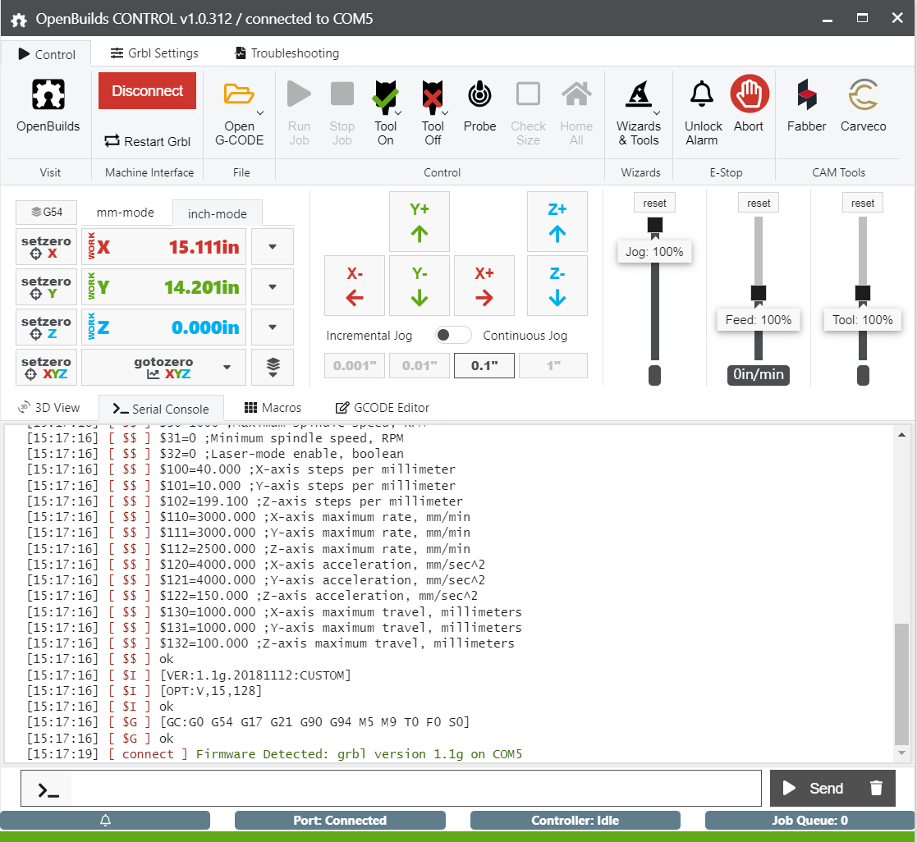

Connect to the Arduino with the software and select Wizards and Tools

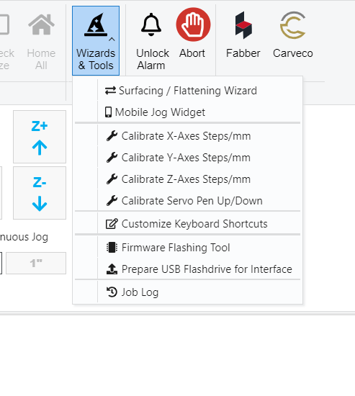

Select Firmware Flashing tool

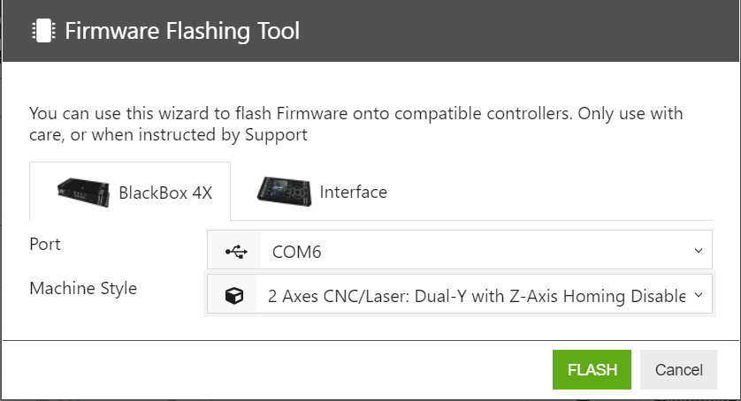

Copy these settings, make sure you have BlackBox4x selected. Your port number (Com 6) will vary depending on what computer you are using. Click Flash and it’s complete.

Next you have to configure the GRBL settings for the machine.

Move over to the GRBL settings tab, you need to be connected to the machine to do this, on the Openbuilds software home screen and select the custom machine and copy the settings to the GRBL Settings spreadsheet.

If you are using the Z-Axis add-on select 3 Axis CNC/Laser

That’s it, you are done.